[ISSN : 2456-3307](http://ijsrcseit.com/) (www.ijsrcseit.com) doi : <https://doi.org/10.32628/CSEIT206463>

Diabetes Prediction Using Machine Learning

## Harsha MS

BE, Department of EEE, Dayananda Sagar College of Engineering, Bengaluru, Karnataka, India

|  |  |
| --- | --- |
| **Article Info** Volume 6, Issue 4  Page Number: 294-305 Publication Issue:  July-August-2020  **Article History** Accepted: 25 July 2020  Published: 30 July 2020 | **ABSTRACT**  Diabetes is a chronic disease with the potential to cause a worldwide health care crisis. According to International Diabetes Federation 382 million people are living with diabetes across the whole world. By 2035, this will be doubled as 592 million. Diabetes is a disease caused due to the increase level of blood glucose. This high blood glucose produces the symptoms of frequent urination, increased thirst, and increased hunger. Diabetes is a one of the leading cause of blindness, kidney failure, amputations, heart failure and stroke. When we eat, our body turns food into sugars, or glucose. At that point, our pancreas is supposed to release insulin. Insulin serves as a key to open our cells, to allow the glucose to enter and allow us to use the glucose for energy. But with diabetes, this system does not work. Type 1 and type 2 diabetes are the most common forms of the disease, but there are also other kinds, such as gestational diabetes, which occurs during pregnancy, as well as other forms. Machine learning is an emerging scientific field in data science dealing with the ways in which machines learn from experience. The aim of this project is to develop a system which can perform early prediction of diabetes for a patient with a higher accuracy by combining the results of different machine learning techniques. The algorithms like K nearest neighbour, Logistic Regression, Random Forest, Support vector machine and Decision tree are used. The accuracy of the model using each of the algorithms is calculated. Then the one with a good accuracy is taken as the model for predicting the diabetes.  **Keywords:** Machine Learning, Diabetes, Decision tree, K nearest neighbour,  Logistic Regression, Support vector Machine, Accuracy. |

## INTRODUCTION

Diabetes is the fast-growing disease among the people even among the youngsters.

In understanding diabetes and how it develops, we need to understand what happens in the body without diabetes. Sugar (glucose) comes from the

foods that we eat, specifically carbohydrate foods. Carbohydrate foods provide our body with its main energy source everybody, even those people with diabetes, needs carbohydrate. Carbohydrate foods include bread, cereal, pasta, rice, fruit, dairy products and vegetables (especially starchy vegetables). When we eat these foods, the body breaks them down into

glucose. The glucose moves around the body in the bloodstream. Some of the glucose is taken to our brain to help us think clearly and function. The remainder of the glucose is taken to the cells of our body for energy and also to our liver, where it is stored as energy that is used later by the body. In order for the body to use glucose for energy, insulin is required. Insulin is a hormone that is produced by the beta cells in the pancreas. Insulin works like a key to a door. Insulin attaches itself to doors on the cell, opening the door to allow glucose to move from the blood stream, through the door, and into the cell. If the pancreas is not able to produce enough insulin (insulin deficiency) or if the body cannot use the insulin it produces (insulin resistance), glucose builds up in the bloodstream (hyperglycemia) and diabetes develops. Diabetes Mellitus means high levels of sugar (glucose) in the blood stream and in the urine.

## Types of Diabetes

**Type 1** diabetes means that the immune system is compromised and the cells fail to produce insulin in sufficient amounts. There are no eloquent studies that prove the causes of type 1 diabetes and there are currently no known methods of prevention.

**Type 2** diabetes means that the cells produce a low quantity of insulin or the body can’t use the insulin correctly. This is the most common type of diabetes, thus affecting 90% of persons diagnosed with diabetes. It is caused by both genetic factors and the manner of living.

**Gestational** diabetes appears in pregnant women who suddenly develop high blood sugar. In two thirds of the cases, it will reappear during subsequent pregnancies. There is a great chance that type 1 or type 2 diabetes will occur after a pregnancy affected by gestational diabetes.

## Symptoms of Diabetes

* Frequent Urination
* Increased thirst
* Tired/Sleepiness
* Weight loss
* Blurred vision
* Mood swings
* Confusion and difficulty concentrating
* frequent infections

## Causes of Diabetes

Genetic factors are the main cause of diabetes. It is caused by at least two mutant genes in the chromosome 6, the chromosome that affects the response of the body to various antigens. Viral infection may also influence the occurrence of type 1 and type 2 diabetes. Studies have shown that infection with viruses such as rubella, Coxsackievirus, mumps, hepatitis B virus, and cytomegalovirus increase the risk of developing diabetes.

## LITERATURE REVIEW

Yashoda al.[1] uses the classification on diverse types of datasets that can be accomplished to decide if a person is diabetic or not. The diabetic patient’s data set is established by gathering data from hospital warehouse which contains two hundred instances with nine attributes. These instances of this dataset are referring to two groups i.e. blood tests and urine tests. In this study the implementation can be done by using WEKA to classify the data and the data is assessed by means of 10-fold cross validation approach, as it performs very well on small datasets, and the outcomes are compared. The naïve Bayes, J48, REP Tree and Random Tree are used. It was concluded that J48 works best showing an accuracy of 60.2% among others.

Aishwarya al. [2] aims to discover solutions to detect the diabetes by investigating and examining the patterns originate in the data via classification analysis by using Decision Tree and Naïve Bayes algorithms. The research hopes to propose a faster and more efficient method of identifying the disease that will help in well-timed cure of the patients. Using PIMA dataset and cross validation approach the study concluded that J48 algorithm gives an accuracy rate of 74.8% while the naïve Bayes gives an accuracy of 79.5% by using 70:30 split.

Gupta et al. [3] aims to find and calculate the accuracy, sensitivity and specificity percentage of numerous classification methods and also tried to compare and analyze the results of several classification methods in WEKA, the study compares the performance of same classifiers when implemented on some other tools which includes RapidMiner and MATLAB using the same parameters (i.e. accuracy, sensitivity and specificity). They applied JRIP, Jgraft and Bayes Net algorithms. The result shows that Jgraft shows highest accuracy i.e. 81.3%, sensitivity is 59.7% and specificity is 81.4%. It was also concluded that WEKA works best than MATLAB and RapidMiner.

Lee et al. [4] focus on applying a decision tree algorithm named as CART on the diabetes dataset

after applying the resample filter over the data. The author emphasis on the class imbalance problem and the need to handle this problem before applying any algorithm to achieve better accuracy rates. The class imbalance is a mostly occur in a dataset having dichotomous values, which means that the class variable have two possible outcomes and can be handled easily if observed earlier in data preprocessing stage and will help in boosting the accuracy of the predictive model.

## METHODOLOGY

In this section we shall learn about the various classifiers used in machine learning to predict diabetes. We shall also explain our proposed methodology to improve the accuracy. Five different methods were used in this paper. The different methods used are defined below. The output is the accuracy metrics of the machine learning models. Then, the model can be used in prediction.

## Dataset Description

The diabetes data set was originated from https://[www.kaggle.com/johndasilva/diabetes.](http://www.kaggle.com/johndasilva/diabetes)

Diabetes dataset containing 2000 cases. The objective is to predict based on the measures to predict if the patient is diabetic or not.

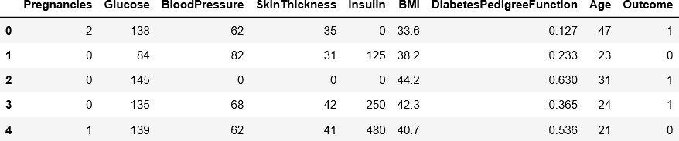

➔ The diabetes data set consists of 2000 data points, with 9 features each.

➔ “Outcome” is the feature we are going to predict, 0 means No diabetes, 1 means diabetes.



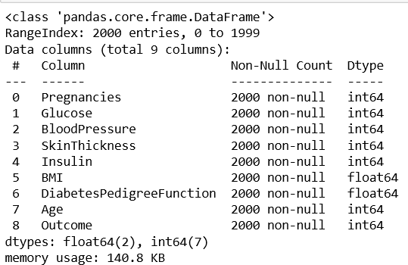

➔ There is no null values in dataset.

Dataset

Preprocess Data

Applied Algorithm s

Performance Evaluation on Various Measures

Result

Comparative Analysis Based on Accuracy

## Proposed Model Diagram

1. **RESULT & DISCUSSION**

**Correlation Matrix:**

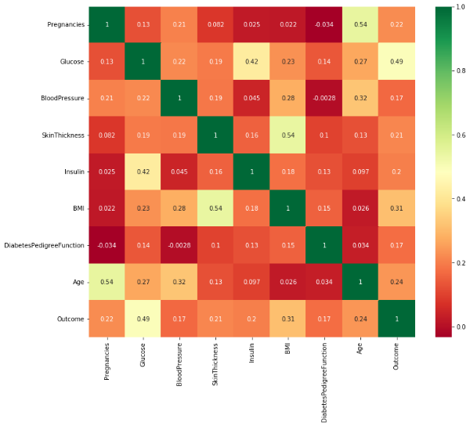

It is easy to see that there is no single feature that has a very high correlation with our outcome value. Some of the features have a negative correlation with the outcome value and some have positive.

## Histogram:

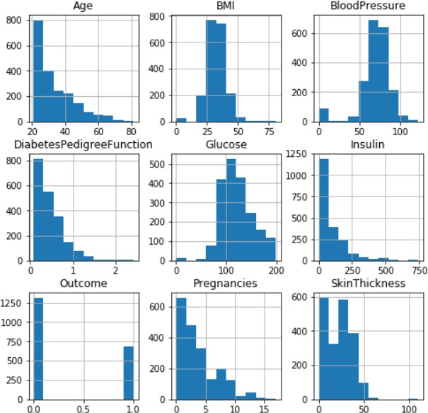

Let’s take a look at the plots. It shows how each feature and label is distributed along different ranges, which further confirms the need for scaling. Next, wherever you see discrete bars, it basically means that each of these is actually a categorical variable. We will need to handle these categorical variables before applying Machine Learning. Our outcome labels have two classes, 0 for no disease and 1 for disease.

## Bar Plot For Outcome Class

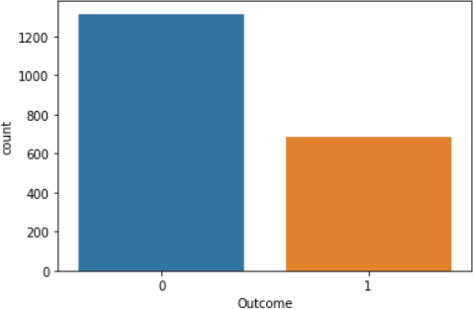

The above graph shows that the data is biased towards datapoints having outcome value as 0 where it means that diabetes was not present actually. The number of non-diabetics is almost twice the number of diabetic patients.

## k-Nearest Neighbors:

The k-NN algorithm is arguably the simplest machine learning algorithm. Building the model consists only of storing the training data set. To make a prediction for a new data point, the algorithm finds the closest data points in the training data set, its “nearest neighbors.”

First, let’s investigate whether we can confirm the connection between model complexity and accuracy:

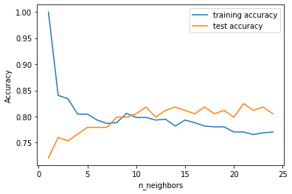

The above plot shows the training and test set accuracy on the y-axis against the setting of n_neighbors on the x- axis. Considering if we choose one single nearest neighbor, the prediction on the training set is perfect. But when more neighbors are considered, the training accuracy drops, indicating that using the single nearest neighbor leads to a model that is too complex. The best performance is somewhere around 9 neighbors.

|  |  |
| --- | --- |
| Training Accuracy | 0.81 |
| Testing Accuracy | 0.80 |

## Table-1

**Logistic regression:**

|  |  |
| --- | --- |
| **Training Accuracy** | **0.76** |
| **Testing Accuracy** | **0.81** |

Logistic Regression is one of the most common classification algorithms.

## Random Forest:

This classifier takes the concept of decision trees to the next level. It creates a forest of trees where each tree is formed by a random selection of features from the total features.

|  |  |
| --- | --- |
| **Training Accuracy** | **1.00** |
| **Testing Accuracy** | **0.805** |

## Feature importance in Random Forest:

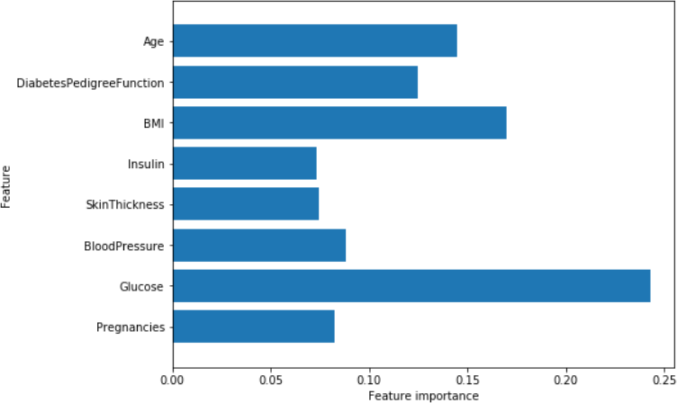

Similarly to the single decision tree, the random forest also gives a lot of importance to the “Glucose” feature, but it also chooses “BMI” to be the 2nd most informative feature overall.

## Support Vector Machine:

This classifier aims at forming a hyper plane that can separate the classes as much as possible by adjusting the distance between the data points and the hyper plane. There are several kernels based on which the hyper plane is decided. I tried four kernels namely, linear, poly, rbf, and sigmoid

As can be seen from the plot above, the linear kernel performed the best for this dataset and achieved a score of 77%.

SVM ACCURACY FOR DIFFERENT KERNELS

0.9

0.8

0.7

0.6

0.5

0.4

0.3

0.2

0.1

0

L I N E A R

P O L Y

R V F

S I G M O I D

KERNELS

0.482

0.774

0.774

0.778

ACCURACY

## Accuracy Comparison:

|  |  |  |
| --- | --- | --- |
| Algorithms | Training Accuracy | Testing Accuracy |
| k-Nearest Neighbors | 81% | 80% |
| Logistic Regression | 76% | 81% |
| Random Forest | 100% | 81% |
| SVM | 81% | 77% |

**Table-5**

Table-5 shows the accuracy values for all five machine learning algorithms.

Table-5 shows that Decision Tree algorithm gives the best accuracy with 98% training accuracy and 99% testing accuracy.

## CONCLUSION AND FUTURE WORK

One of the important real-world medical problems is the detection of diabetes at its early stage. In this study, systematic efforts are made in designing a system which results in the prediction of diabetes. During this work, five machine learning classification algorithms are studied and evaluated on various measures. Experiments are performed on john Diabetes Database. Experimental results determine the adequacy of the designed system with an achieved accuracy of 81% using KNN algorithm.

In future, the designed system with the used machine learning classification algorithms can be used to predict or diagnose other diseases. The work can be extended and improved for the automation of diabetes analysis including some other machine learning algorithms.

## ACKNOWLEDGEMENT

I have completed this work under the mentorship of Dr. Pankaj Agarwal (Professor & Head) & Ms. Sapna Yadav (Assistant Professor), Department of Computer Science & Engineering at IMS Engineering College, Ghaziabad. I am doing a online summer internship on Machine Learning where I have learnt the various Machine Learning Algorithms from both of my mentors as Course Instructors. This work is been assigned as project assignments to us.

I would like to express my special thanks to both of my mentors for inspiring us to complete the work & write this paper. Without their active guidance, help, cooperation & encouragement, I would not have my headway in writing this paper. I am extremely thankful for their valuable guidance and support on completion of this paper.

I extend my gratitude to “IMS Engineering College” for giving me this opportunity. I also acknowledge with a deep sense of reverence, my gratitude towards my parents and member of my family, who has always supported me morally as well as economically. Any omission in this brief acknowledgement does not mean lack of gratitude.

## REFERENCES

[1]. Aljumah, A.A., Ahamad, M.G., Siddiqui, M.K., 2013. Application of data mining: Diabetes health care in young and old patients. Journal of King Saud University - Computer and Information Sciences 25, 127–136. doi:10.1016/j.jksuci.2012.10.003.

[2]. Arora, R., Suman, 2012. Comparative Analysis of Classification Algorithms on Different Datasets using WEKA. International Journal of Computer Applications 54, 21–25. doi:10.5120/8626-2492.

[3]. Bamnote, M.P., G.R., 2014. Design of Classifier for Detection of Diabetes Mellitus Using Genetic

Programming. Advances in Intelligent Systems and Computing 1, 763–770. doi:10.1007/978-3-

319-11933-5.

[4]. Choubey, D.K., Paul, S., Kumar, S., Kumar, S., 2017. Classification of Pima indian diabetes dataset using naive bayes with genetic algorithm as an attribute selection, in: Communication and Computing Systems: Proceedings of the International Conference on Communication and Computing System (ICCCS 2016), pp. 451– 455.

[5]. Dhomse Kanchan B., M.K.M., 2016. Study of Machine Learning Algorithms for Special Disease Prediction using Principal of Component Analysis, in: 2016 International Conference on Global Trends in Signal Processing, Information Computing and Communication, IEEE. pp. 5–10.

[6]. Sharief, A.A., Sheta, A., 2014. Developing a Mathematical Model to Detect Diabetes Using Multigene Genetic Programming. International Journal of Advanced Research in Artificial Intelligence (IJARAI) 3, 54–59. doi:doi:10.14569/IJARAI.2014.031007.

[7]. Sisodia, D., Shrivastava, S.K., Jain, R.C., 2010. ISVM for face recognition. Proceedings - 2010 International Conference on Computational Intelligence and Communication Networks, CICN 2010 , 554–

559doi:10.1109/CICN.2010.109.

[8]. Sisodia, D., Singh, L., Sisodia, S., 2014. Fast and Accurate Face Recognition Using SVM and DCT, in: Proceedings of the Second International Conference on Soft Computing for Problem Solving (SocProS 2012), December 28-30, 2012,

Springer. pp. 1027–1038.

[9]. https://[www.kaggle.com/johndasilva/diabetes](http://www.kaggle.com/johndasilva/diabetes) [10].Rani, A. S., & Jyothi, S. (2016, March).

Performance analysis of classification algorithms under different datasets. In Computing for Sustainable Global Development (INDIACom), 2016 3rd International Conference on (pp. 1584- 1589). IEEE.